**DVT driver**

**Design based Atlas device from CISSOID**

|  |  |  |
| --- | --- | --- |
| **Version** | **Date** | **Created**  **by / at** |
| **1.00** | **2016-07-05** | **S.Kulik**  **2016-07-05** |

# CISSOID Atlas

Main features

* Temperature range: -55°C to 225°C (and still on-going)
* Validated at 225°C for 1000 hours
* Gate drive supply voltage: 5 to 30V
* Separate logic level control inputs
* Output current: up to 2 x ±2A @ 225°C
* Supply Voltage: 5V to 30V
* Capable to drive normally-On and normally-Off power devices
* Available Package: Ceramic SOIC28

**DESCRIPTION**

CHT-ATLAS is a high-temperature, high reliability power transistor driver integrated circuit specifically designed to drive widebandgap power transistors, in particular Gallium Nitride (GaN) and Silicon Carbide (SiC) devices including normally-On and normally-Off JFETs, MOSFETs and BJTs. It is also used with standard silicon MOSFETs and IGBTs in standard temperature applications (e.g. 125°C) where it brings an increase in reliability and lifetime by an order of magnitude compared to traditional solutions. The circuit features 2 independent push-pull channels capable of sourcing/sinking 2A each. When configured together to drive a single power switch, the combination of the 2 distinct channels allows driving of specific devices that require for instance a dynamic pulse of current in combination with a continuous current in order to be properly turned-on. The circuit includes a soft-shut-down capability that slowly shuts down the power transistor in case of fault.

Functional bloch diagram

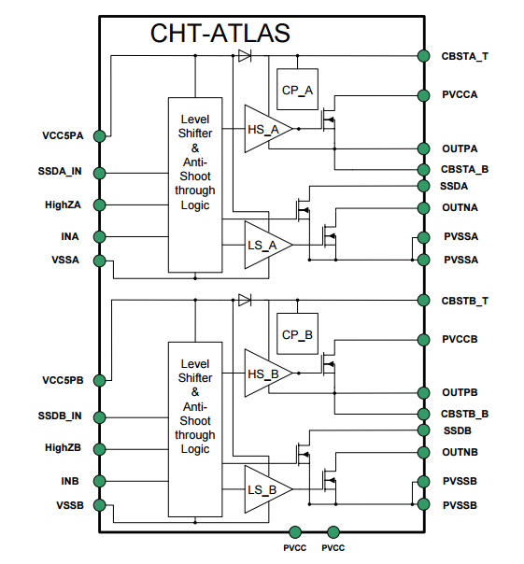

Schematic

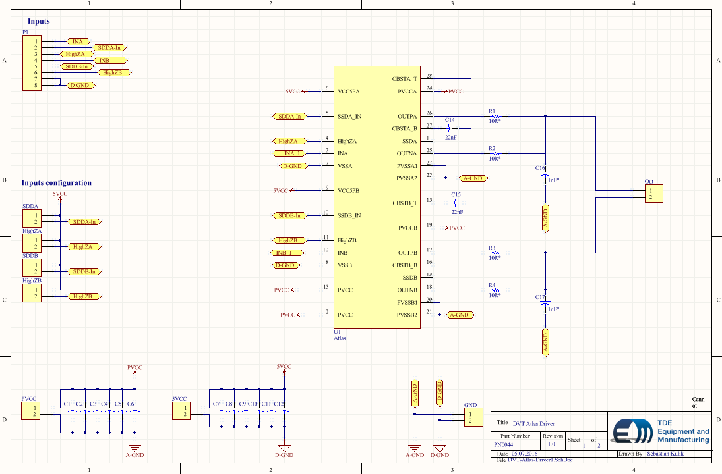

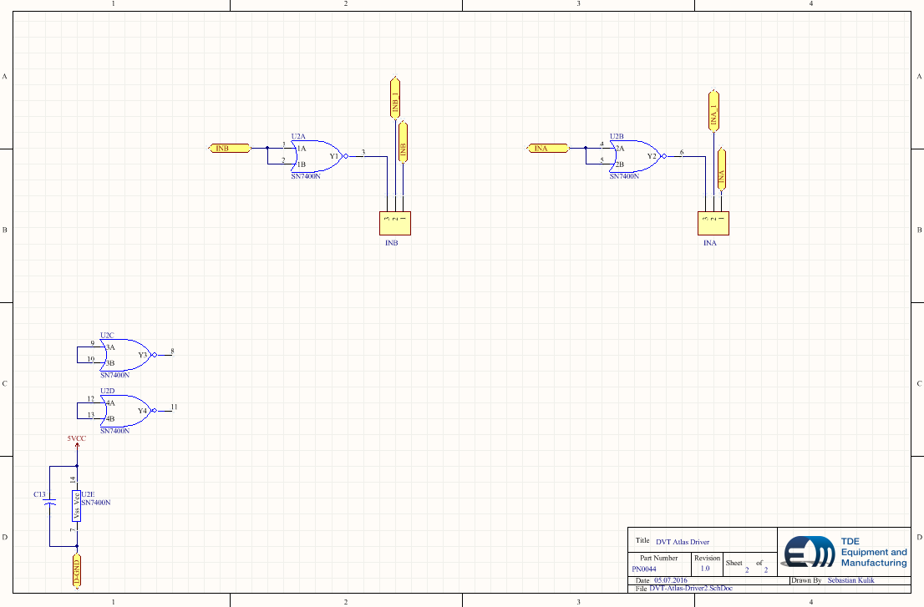

PCBs

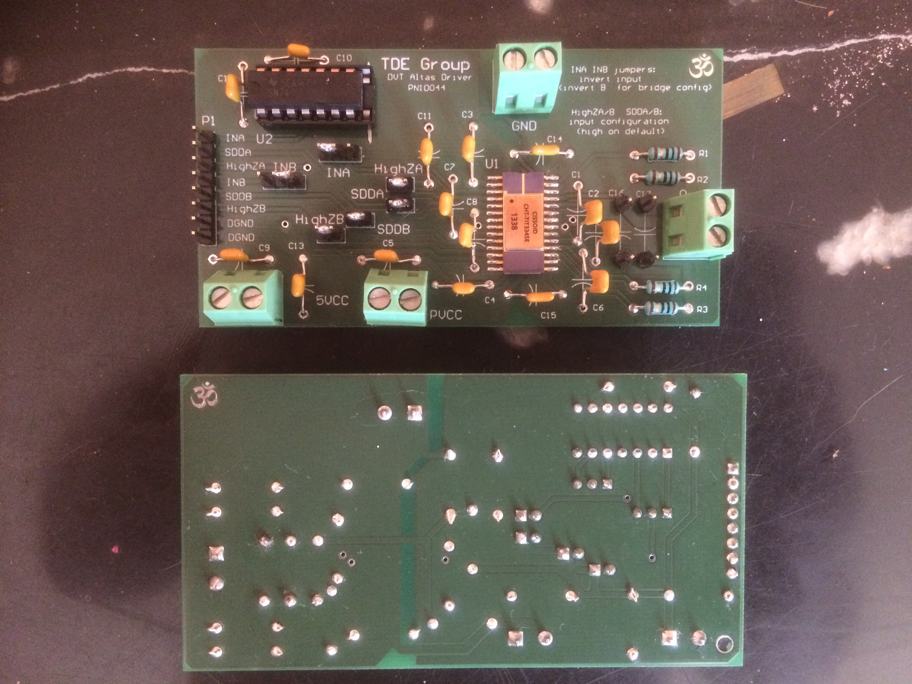

SN7400 inverted Schmitt-Trigger device is only for test build only to use single ended function generator on functional tests.

Atlas device configured to use in bridge mode, test Vpp voltage is 20V, 5Vcc and 20Vpp grounds are shorted on GND connector.

Color legend:

Yellow (1): Positive output

Cyan (2): Negative output

Blue (4): generator

Purple (M): math calculated differential output

200kHz

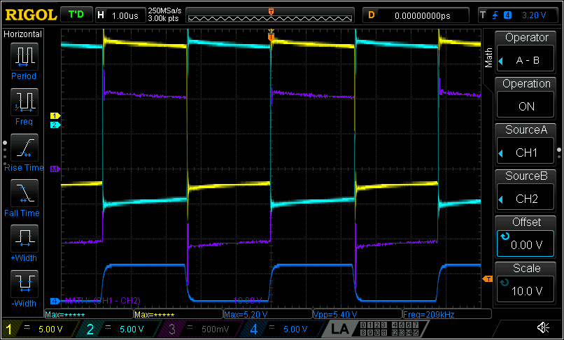

400kHz

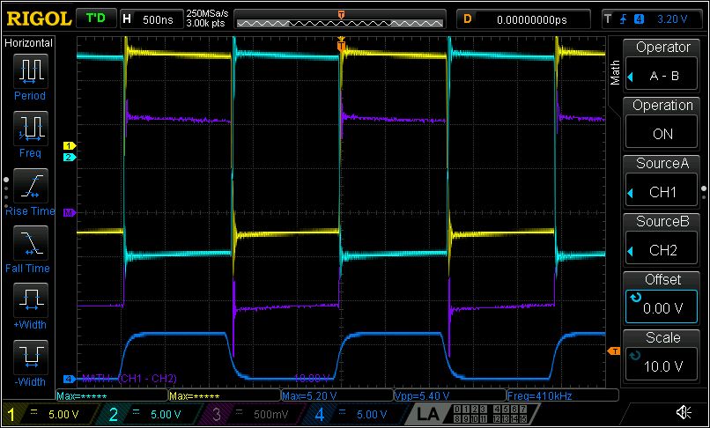

600kHz

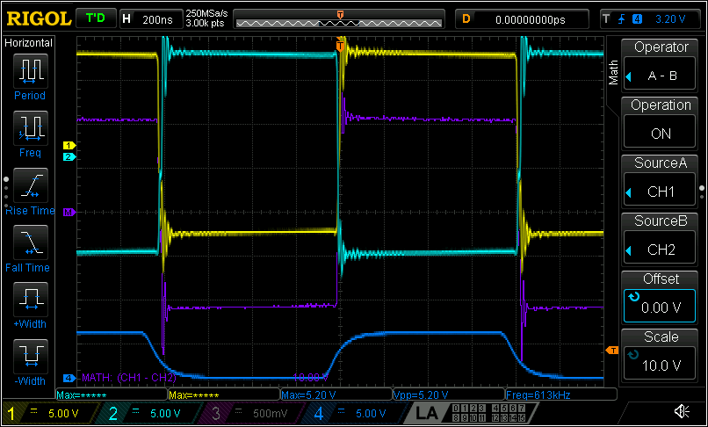

800kHz

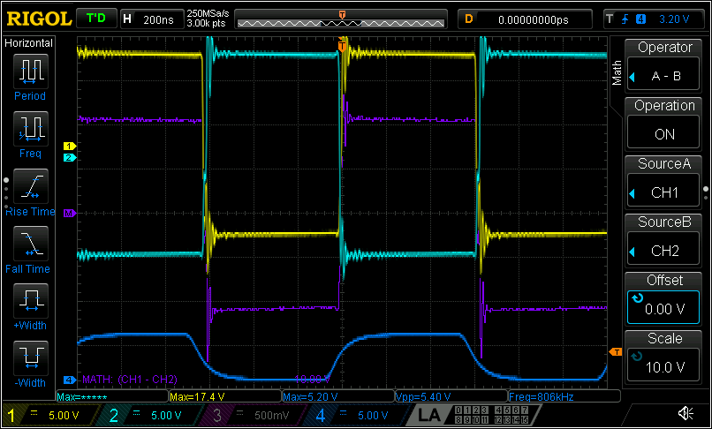

1MHz

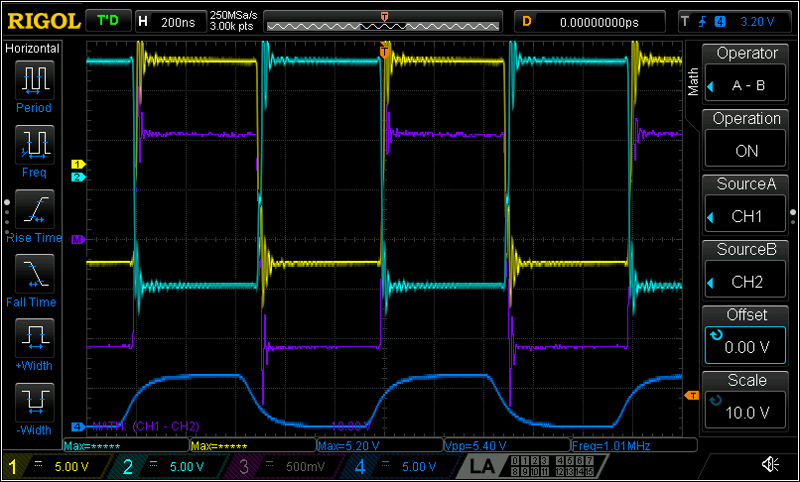

1.2MHz

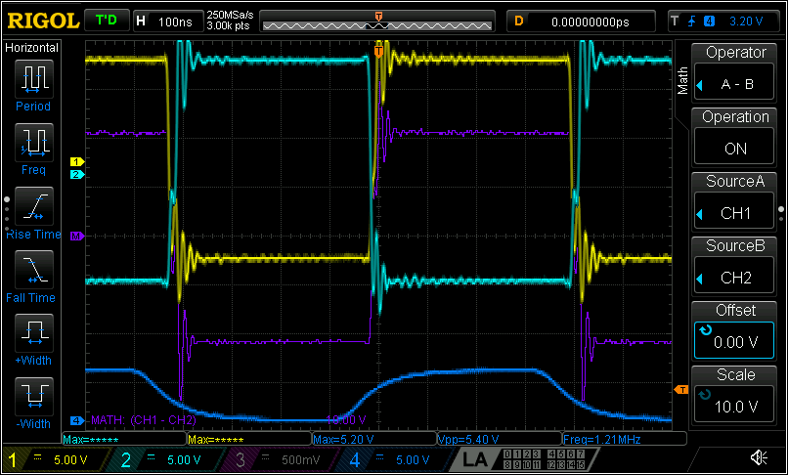

1.4MHz

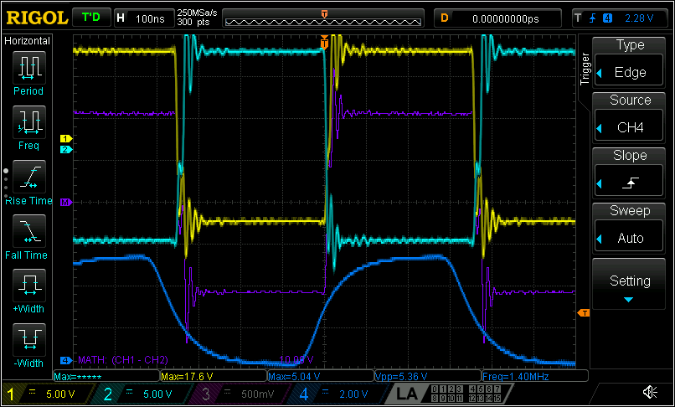

1.6MHz

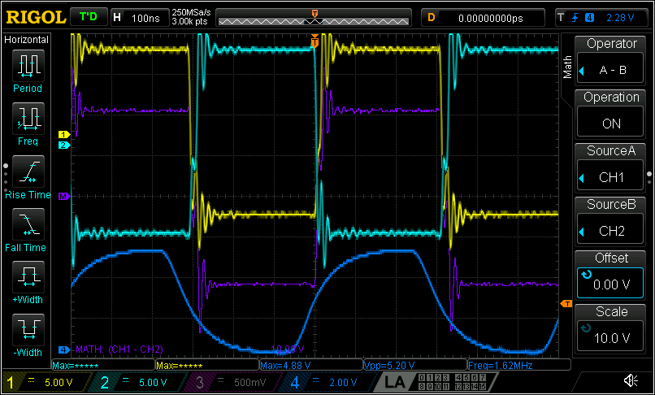

1.8MHz

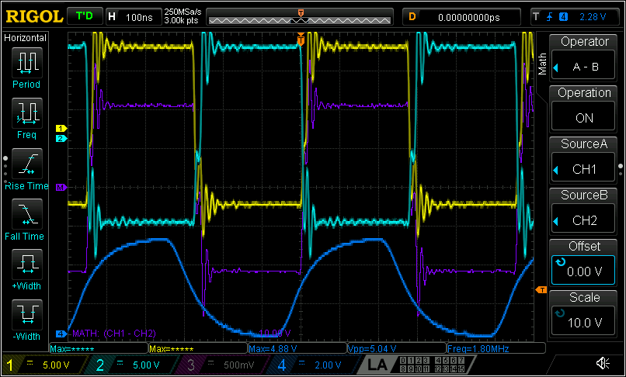

2MHz

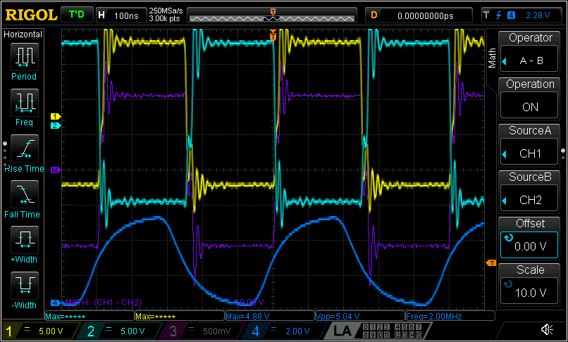

3.5MHz

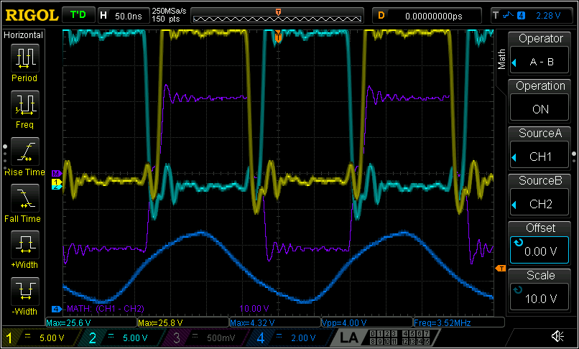

**Summary**

Atlas device works very well and in first tests works stable as well